BCA Green Mark Score Calculator

User Guide
Version 1.0

SUMMARY OF DOCUMENTATION CHANGES

Version No | Date Revised | Summary of Changes
1.0.0 | 06th July 2009 | -

TABLE OF CONTENTS

1 Green Mark Score Calculator – Home Page 3
2 Residential Buildings (Version 3.0) 4
2.1. New Worksheet 4
2.2. Open Worksheet 5
2.3. RB Criteria (in PDF) 6
2.4. New Worksheet 7
2.4.1. Export Worksheet 13
2.4.2. Preview Worksheet 14
2.4.3. Print Worksheet 15
2.4.4. Close 17
2.5. Open Worksheet 18
3 Non-Residential Buildings (Version 3.0) 21
3.1. New Worksheet 21
3.2. Open Worksheet 22
3.3. NRB Criteria (in PDF) 23
3.4. New Worksheet 24
3.4.1. Export Worksheet 31
3.4.2. Preview Worksheet 32
3.4.3. Print Worksheet 33
3.4.4. Close 35
3.5. Open Worksheet 35
4 Green Mark Score Calculator – Contact Us 38
5 Green Mark Score Calculator – Help 39

- Green Mark Score Calculator – Home Page
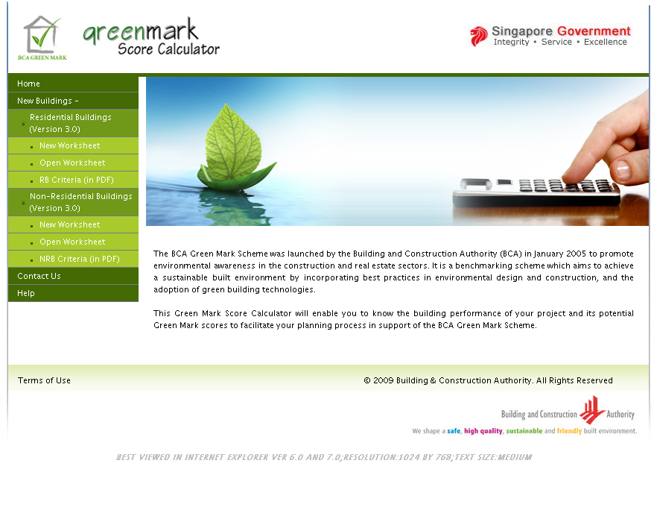
Notes:
- Clicking Home will show the home page
- Clicking New Worksheet will open the new work sheet section in a new window.
- Clicking Open Worksheet will open the Open Worksheet section in a new window.
- Clicking RB Criteria (in PDF) will open the PDF file containing the information about BCA Green Mark for Residential Building Version RB/3.0
- Clicking NRB Criteria (in PDF) will open the PDF file containing the information about BCA Green Mark for Non-Residential Building Version NRB/3.0
- Clicking Contact Us will show the Subject Matter along with Contact persons with contact details in a new window.
- Clicking Help will open the User Guide for BCA Green Mark Score Calculator
Please note that this website is BEST VIEWED IN INTERNET EXPLORER VER 6.0 AND 7.0;RESOLUTION:1024 BY 768;TEXT SIZE:MEDIUM
Please note that pop-ups from this website should be allowed in order to generate PDF files.

- Residential Buildings (Version 3.0)
  - New Worksheet
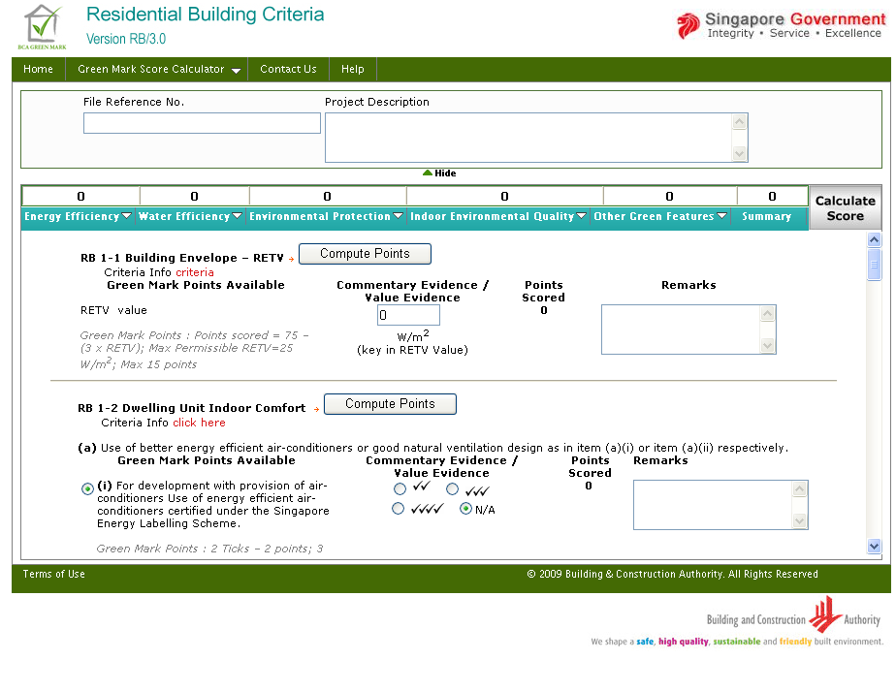
Notes:
- Clicking New Worksheet from the home page will open this page.

  - Open Worksheet
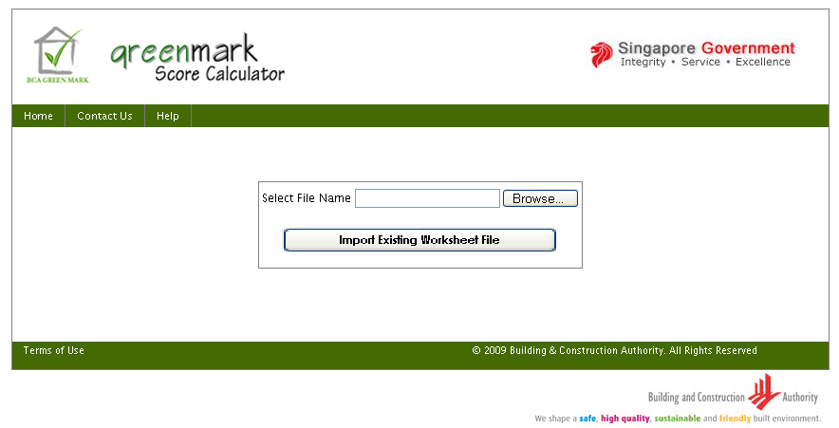
Notes:
- Clicking Open Worksheet from the home page will open this page.

  - RB Criteria (in PDF)
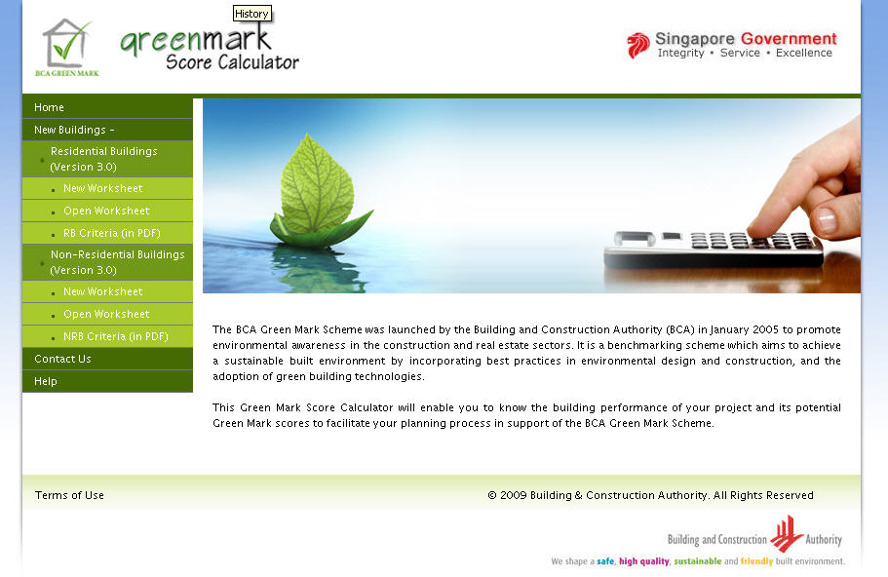
Notes:
- Clicking RB Criteria(in PDF) from the home page will open the PDF file in new window from http://www.bca.gov.sg/GreenMark/others/gm_resiv3.pdf, this PDF file contains the information about BCA Green Mark for Residential Building Version RB/3.0

  - New Worksheet
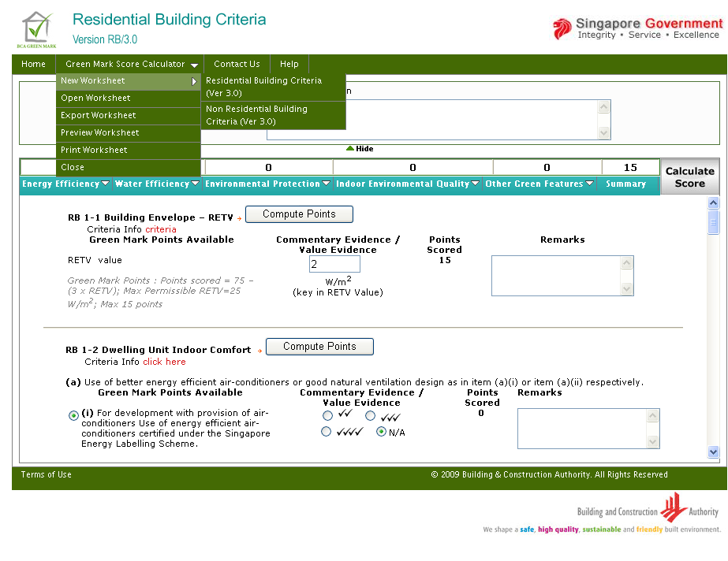
Notes:
- Hovering on New Worksheet , will display the criteria sections as sub menus, when click on any of these will open the page in new window.
- Initially, the page is loaded with all the sub sections under the section Energy Efficiency.

To view particular sub section

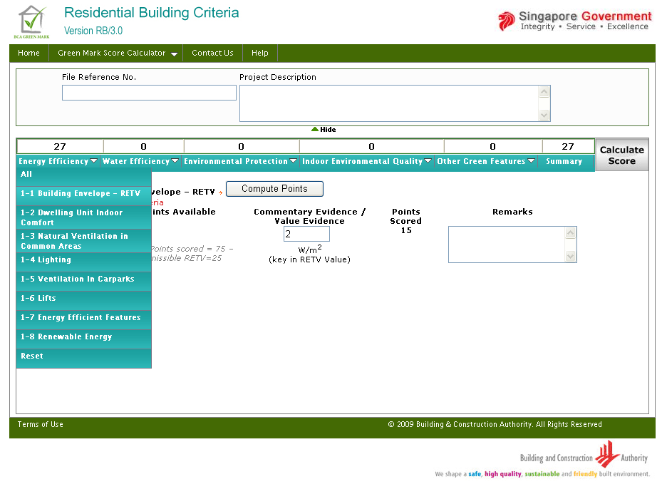

Notes:
- Upon clicking 1-1 Building Envelope – RETV in Energy Efficiency section, will display the particular sub section alone. This can be done for all sections and sub sections.

Calculate Score & Compute Points:
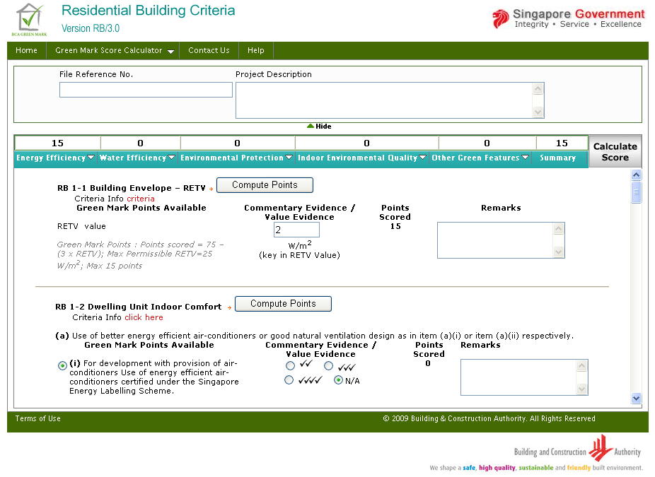
Notes:
- Will have all the scores blank and can input values in Energy Efficiency, Water Efficiency, Environmental Protection, Indoor Environmental Quality, Other Green Features and can calculate GM Score by using Compute Points and / or Calculate Score button.
- Compute Points will calculate and show the GM score only for that particular section
- Calculate Score will calculate and show the GM score for all the sections
Summary Page:
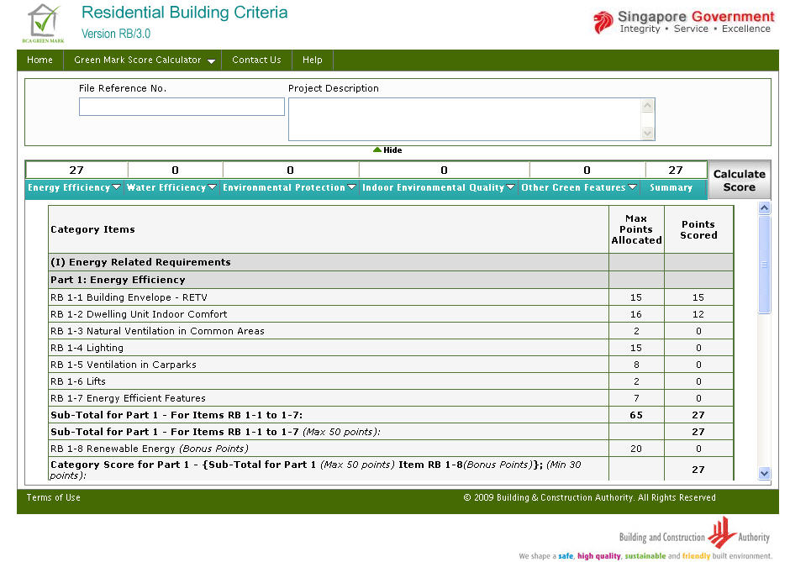
Notes:
- When clicked “Summary” will present the scores obtained in each sub category under a particular category.

Reset Score for RB

Before Reset:
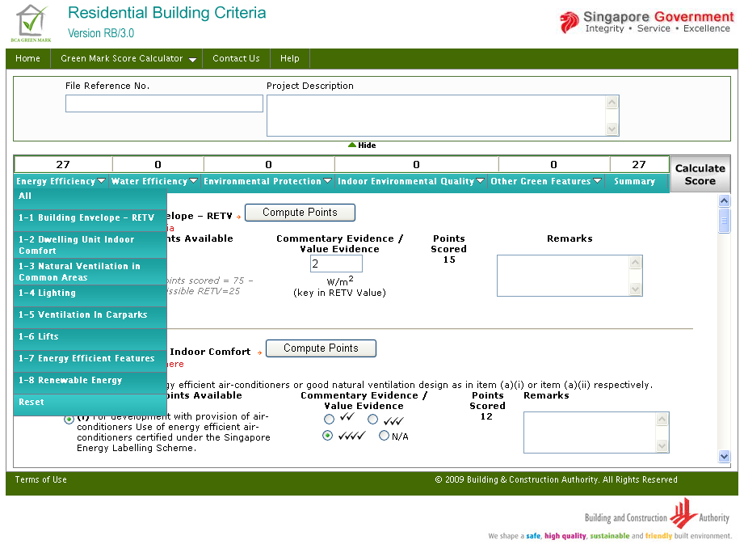
Notes:
- Upon clicking Reset in Energy Efficiency section, will reset all the inputs and outputs produced in the corresponding section and also the Top Score obtained for the corresponding section, which is also shown below. All the sections has got Reset to reset their corresponding sections.

After Reset:
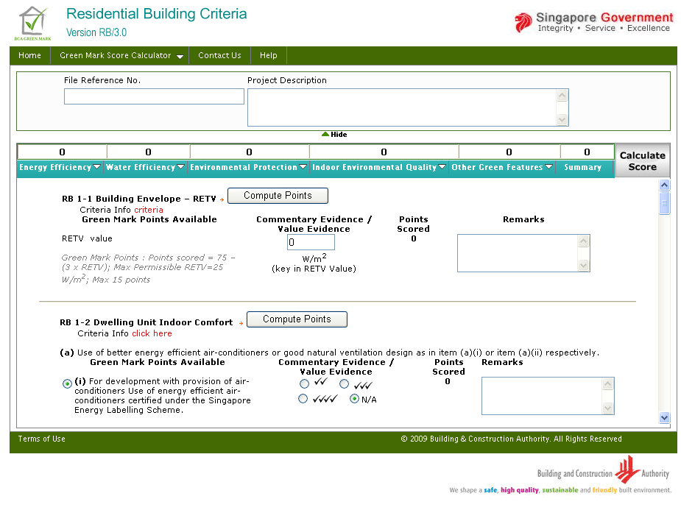
Notes:
- After reset in Energy Efficiency section, the scores have been refreshed to zero.

    - Export Worksheet
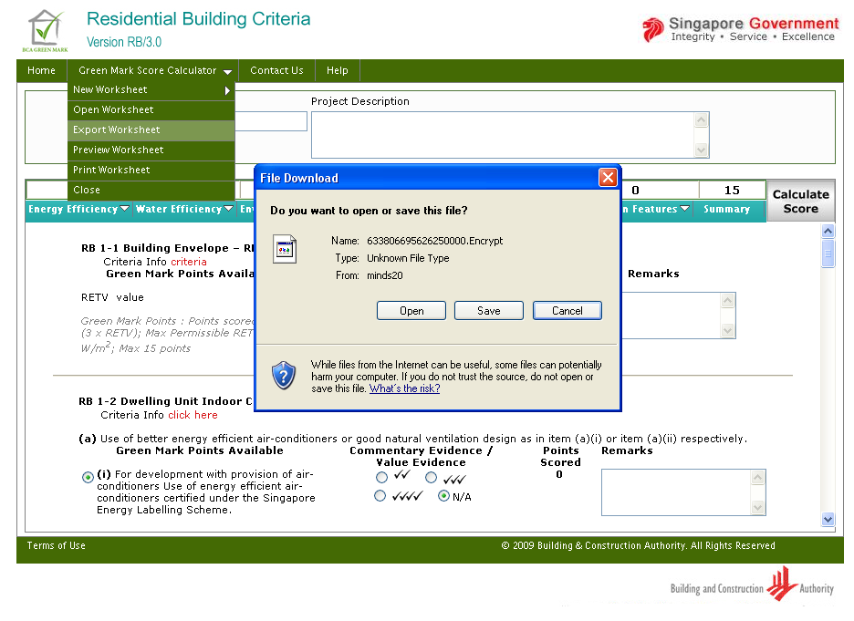
Notes:
- When clicked Export Worksheet , will open a download window showing the encrypted file name, which contains the input entered in project details and criteria section . This file can be saved in local system and can be opened / imported when needed using “Open Worksheet” feature.

    - Preview Worksheet

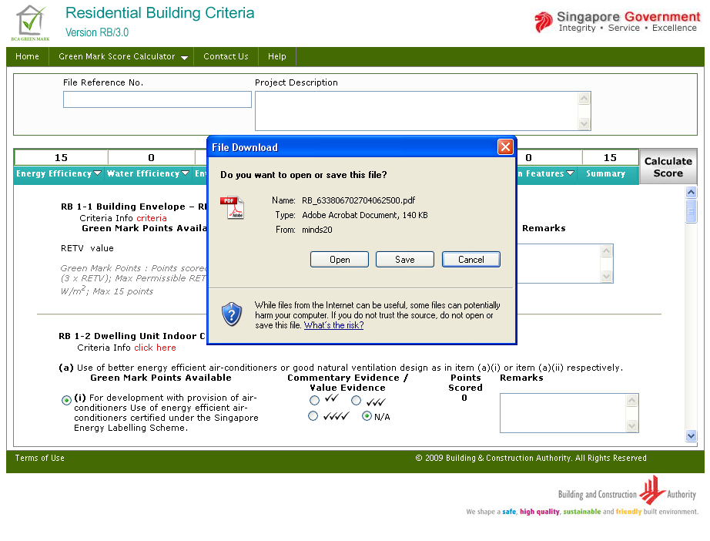
Notes:
- Upon clicking Preview Worksheet will generate the PDF file containing the project detail section inputs and criteria section inputs and outputs.
- Above shown window, contains the download window containing the PDF file for RB, which can be saved in the local system.

    - Print Worksheet

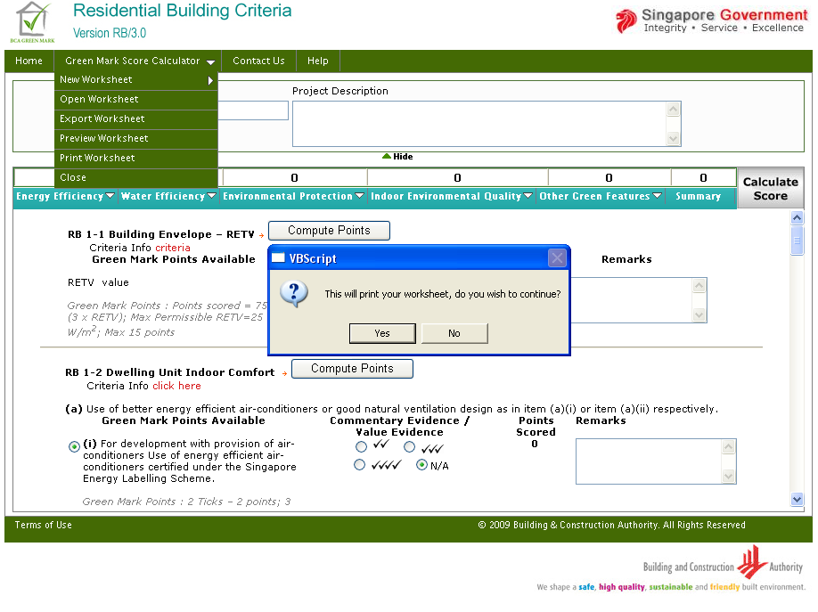
Notes:
- Upon clicking Print Worksheet will ask for confirmation, whether to print the worksheet.
- When clicked ‘yes’, will then calculate the GM score to check whether it meets minimum requirement score or not.
- When clicked ‘No’, will cancel the print option.
- When clicked ‘yes’, the system check is shown below.

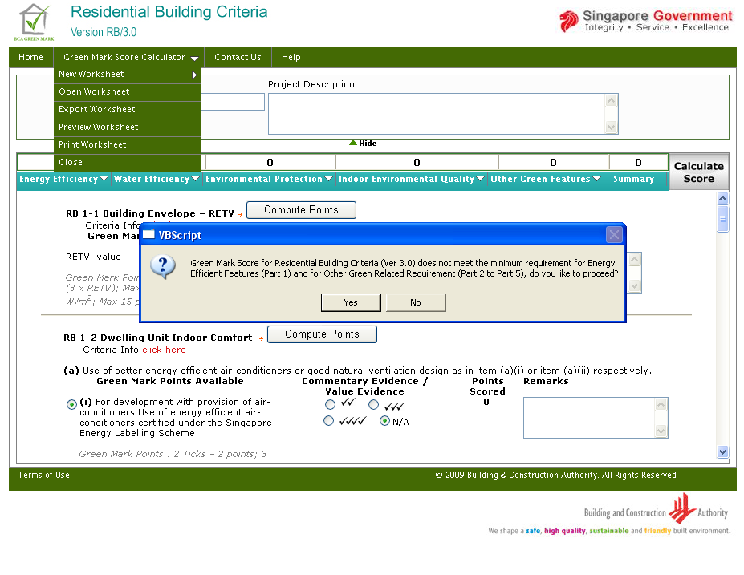
Notes:
- This message describes that, the GM score in part 1 and part 2 to 5, does not meet minimum requirement, and has asked for the confirmation, whether to proceed printing the worksheet.
- Similarly, when part 1 score is < 30, then the message is prompted as “Green Mark Score for Residential Building Criteria (Ver. 3.0) does not meet the minimum requirement for Energy Efficient Features (Part 1), do you like to proceed?”
- Similarly, when part 2 to 5 score is < 20 then the message is prompted as “Green Mark Score for Residential Building Criteria (Ver. 3.0) does not meet the minimum requirement for Other Green Related Requirement (Part 2 to Part 5), do you like to proceed?”
- Whether both meet or do not meet the minimum requirement, system will generate the PDF file containing the project detail section inputs and criteria section inputs and outputs and opens the PDF file in a new window.
    - Close
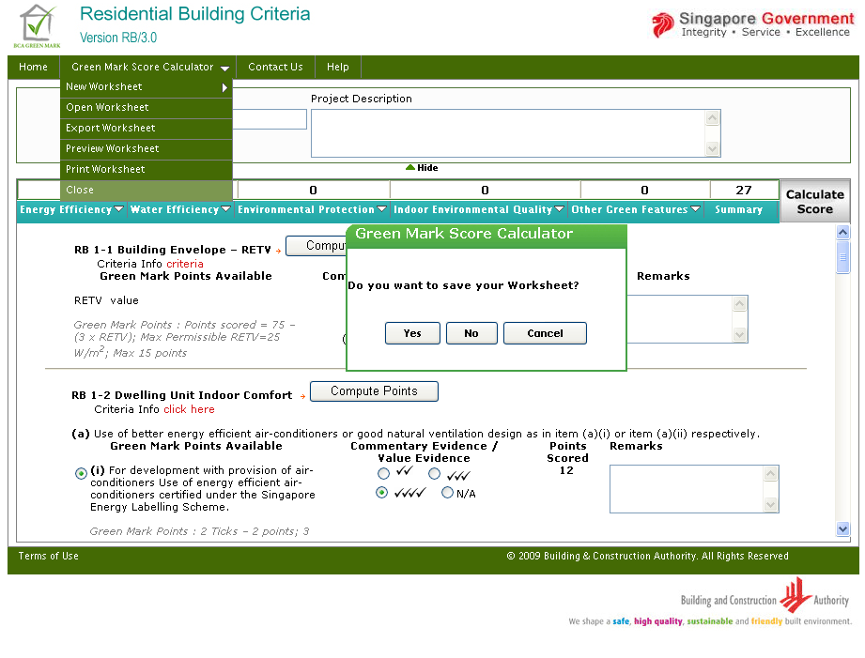
Notes:
- Upon clicking Close will ask for saving the worksheet
- When clicked Yes, will export the worksheet by encrypting the project details section and criteria section.
- When clicked No, will redirect the page to Home Page.
- When clicked Cancel, will not perform any action, which means that the user has cancelled the “close” process.

  - Open Worksheet
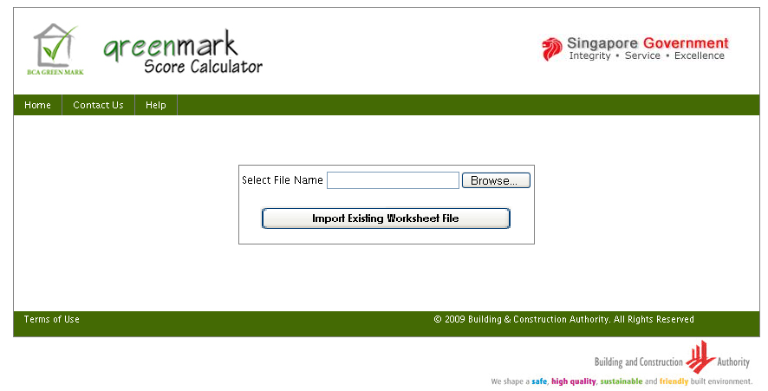
Notes:
- Upon clicking Browse button will open the file open dialog, to fetch the encrypted file saved before, which is shown below.

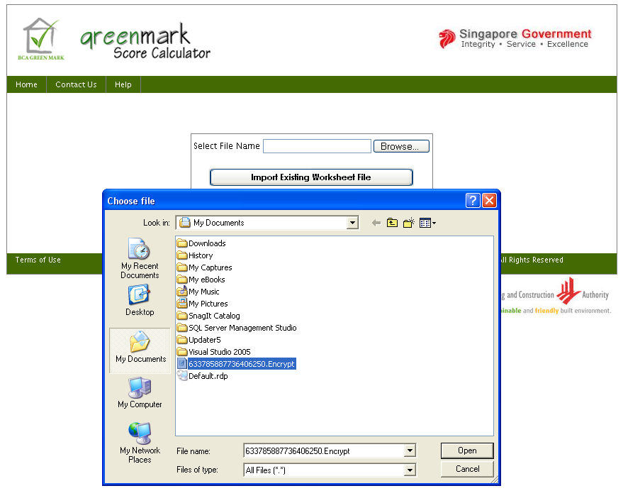
Notes:
- Select the encrypted file from the location saved and then click Open. Then click Import Existing Worksheet File, upon clicking the Import Existing Worksheet File button, will determine the criteria section and opens the corresponding page by retrieving the inputs entered and scores obtained. Further data can be entered and exported again.

After “Import Existing Worksheet File”
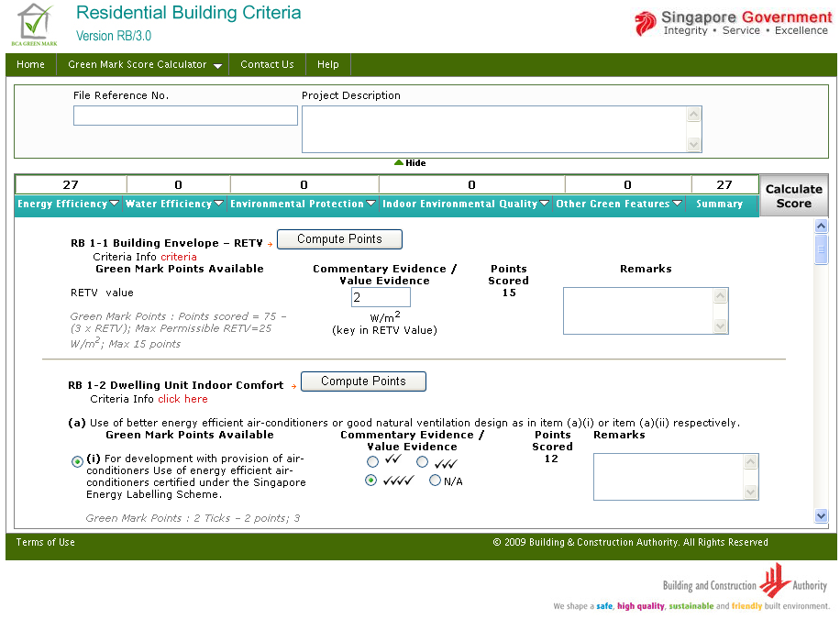
Notes:
- RB page opens by retrieving the inputs given and the scores obtained for those inputs

- Non-Residential Buildings (Version 3.0)
  - New Worksheet
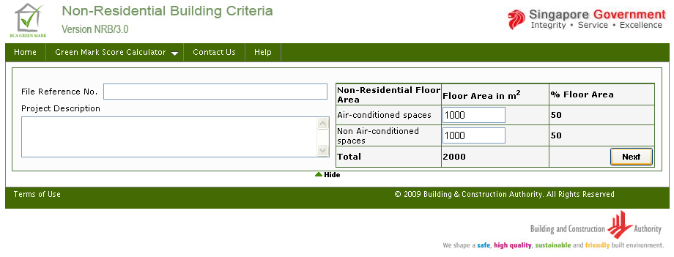
Notes:
- Clicking New Worksheet from the home page will open this page.

  - Open Worksheet
Notes:
- Clicking Open Worksheet from the home page will open this page.
  - NRB Criteria (in PDF)

Notes:
- When click on NRB Criteria (in PDF), will open the PDF file in new window from http://www.bca.gov.sg/GreenMark/others/gm_nonresiv3.pdf, this PDF file contains the information about BCA Green Mark for Non-Residential Building Version NRB/3.0
  - New Worksheet
Notes:
- NRB new worksheet, initially need to provide the air-conditioned spaces and non air-conditioned spaces and click Next will display the criteria section.

After clicking “Next”

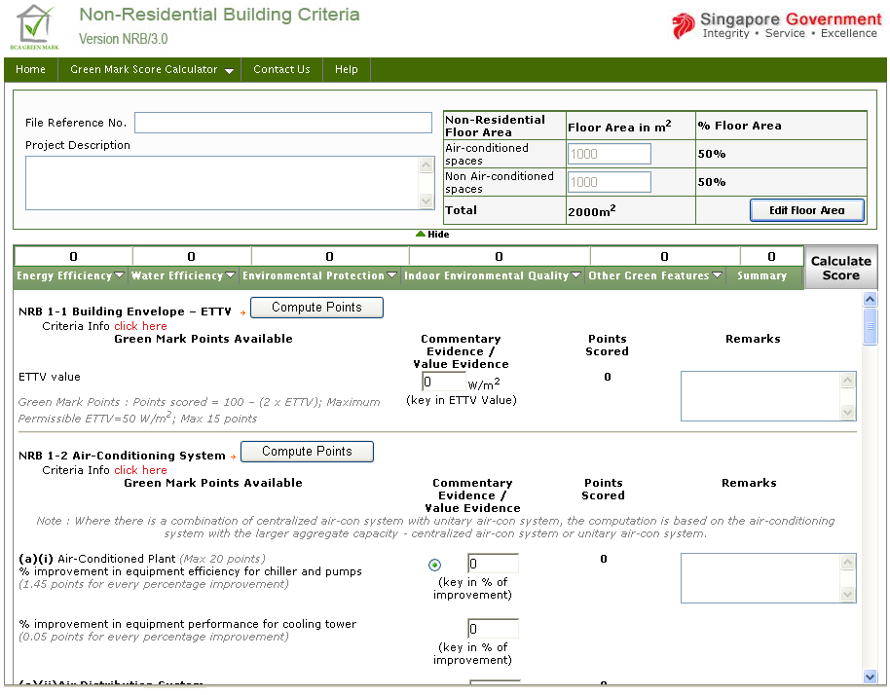
Notes:
- While clicking “Next”, system checks for air-conditioned and non-air conditioned spaces for displaying the sub-section from (1-1 to 1-4) in the section “Energy Efficiency”.
- When air-conditioned spaces input is >=500 m² and non-air conditioned spaces is >= 10%, then the subsection (1-1 to 1-4) gets enabled.
- When air-conditioned spaces input is >=500 m² and non-air conditioned spaces is < 10%, then the subsection (1-1 & 1-2) gets enabled, subsection (1-3 & 1-4) gets disabled.
- When air-conditioned spaces input is < 500 m² and non-air conditioned spaces is >= 10%, then the subsection (1-1 & 1-2) gets disabled, subsection (1-3 & 1-4) gets enabled.
- When air-conditioned spaces input is < 500 m² and non-air conditioned spaces is < 10%, then the subsection (1-1 & 1-2) gets disabled, subsection (1-3 & 1-4) gets disabled.
To view particular sub section
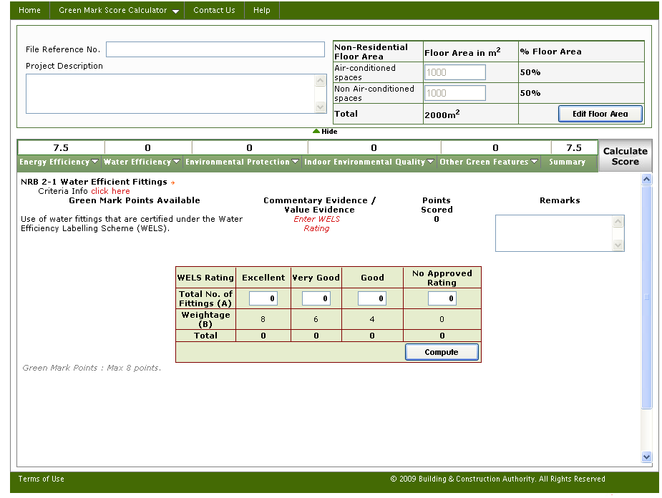
Notes:
- Upon clicking NRB 2-1 Water Efficient Fittings in Water Efficiency section, will display the particular sub section alone. This can be done for all sections and sub sections.

Calculate Score & Compute Points:
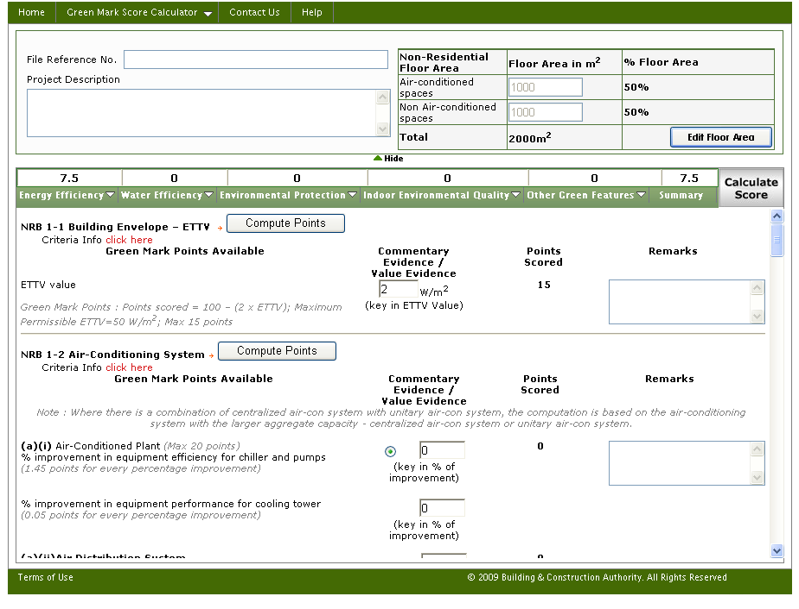
Notes:
- Will have all the scores blank and can input values in Energy Efficiency, Water Efficiency, Environmental Protection, Indoor Environmental Quality, Other Green Features and can calculate GM Score by using Compute Points and / or Calculate Score button.
- Compute Points will calculate and show the GM score only for that particular section
- Calculate Score will calculate and show the GM score for all the sections

Summary Page:
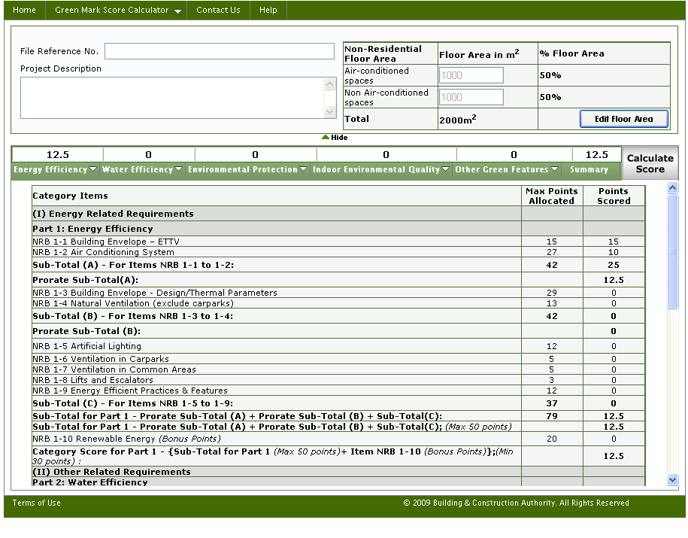
Notes:
- When clicked “summary” will present the scores obtained in each sub category under a particular category.

Reset Score for NRB
Before Reset:
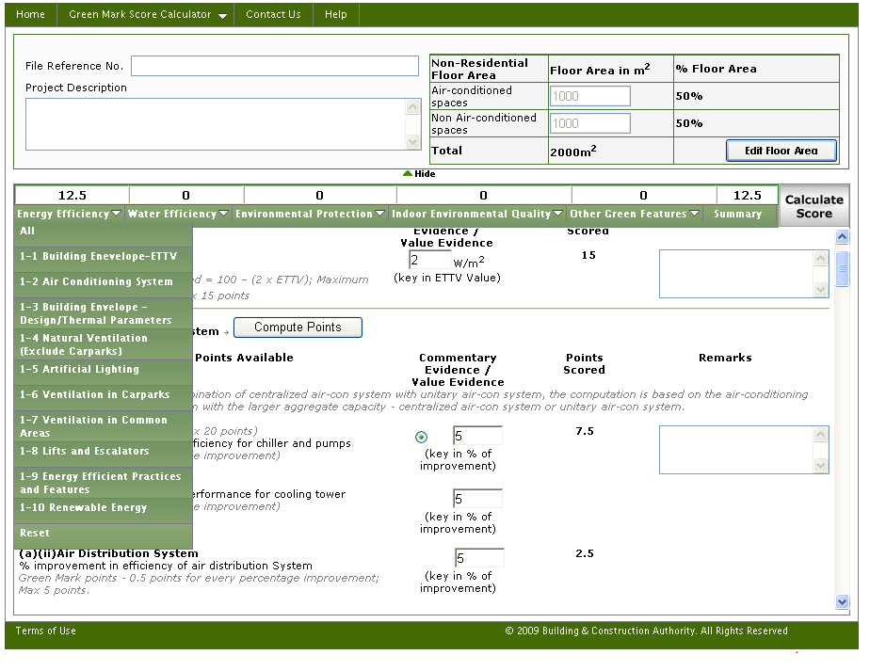
Notes:
- Upon clicking Reset in Energy Efficiency section, will reset all the inputs and outputs produced in the corresponding section and also the Top Score obtained for the corresponding section, which is also shown below. All the sections has got Reset to reset their corresponding sections.

After Reset:
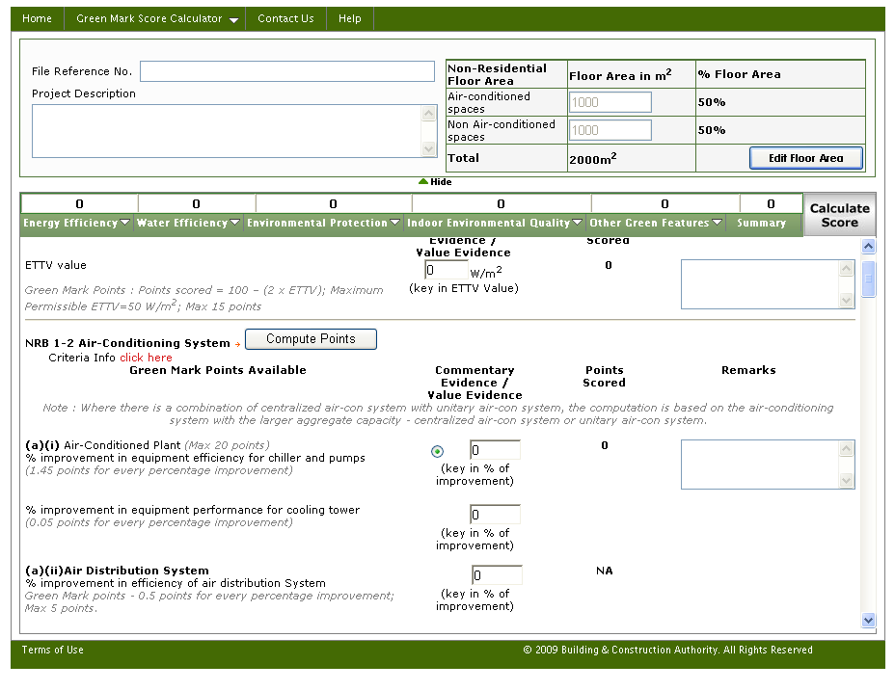
Notes:
- After reset in Energy Efficiency section, the scores have been refreshed to zero.

    - Export Worksheet
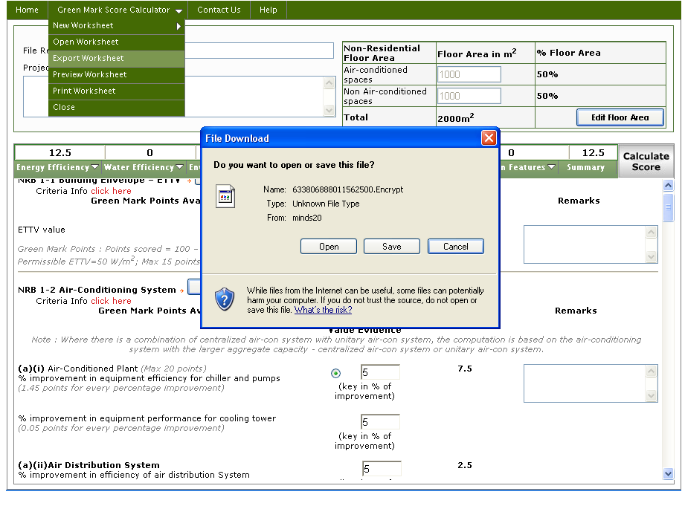
Notes:
- When clicked Export Worksheet , will open a download window showing the encrypted file name, which contains the input entered in project details and criteria section . This file can be saved in local system and can be opened / imported when needed.

    - Preview Worksheet
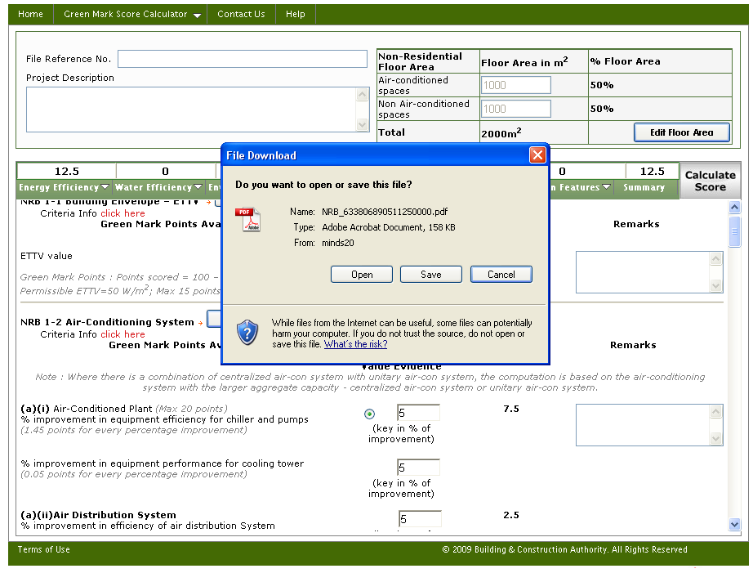

Notes:
- Upon clicking Preview Worksheet will generate the PDF file containing the project detail section inputs and criteria section inputs and outputs.
- Above shown window, contains the download window containing the PDF file for NRB, which can be saved in the local system.

To turn on “pop-up blocker”
( so as to allow Print worksheet)

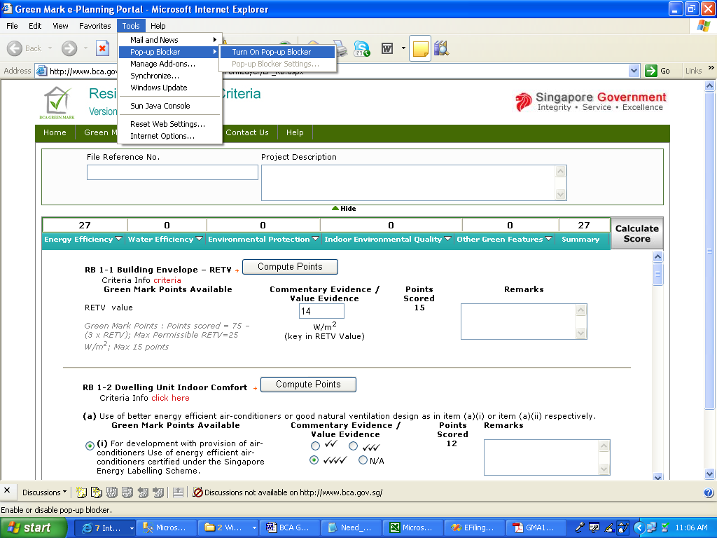
    - Print Worksheet
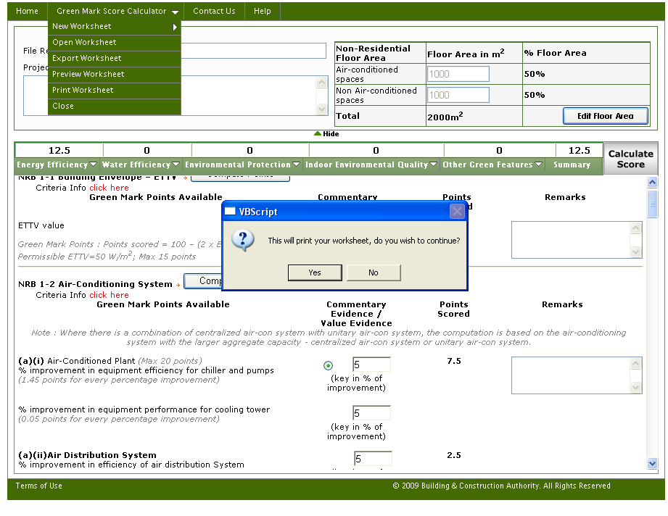
Notes:
- Upon clicking Print Worksheet will ask for confirmation, whether to print the worksheet.
- When clicked ‘yes’, will then calculate the GM score to check whether it does not meet minimum requirement score.
- When clicked ‘No’, will cancel the print option.
- When clicked ‘yes’, the system check is shown below.

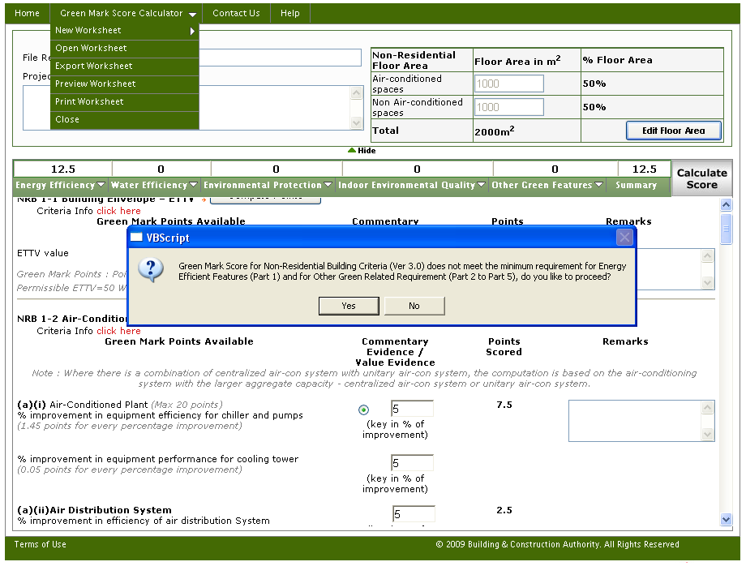
Notes:
- This message describes that, the GM score in part 1 and part 2 to 5, does not meet minimum requirement, and has asked for the confirmation, whether to proceed printing the worksheet.
- Similarly, when part 1 score is < 30, then the message is prompted as “Green Mark Score for Residential Building Criteria (Ver 3.0) does not meet the minimum requirement for Energy Efficient Features (Part 1), do you like to proceed?”
- Similarly, when part 2 to 5 score is < 20 then the message is prompted as “Green Mark Score for Residential Building Criteria (Ver 3.0) does not meet the minimum requirement for Other Green Related Requirement (Part 2 to Part 5), do you like to proceed?”
- Whether both meet the minimum requirement or not, system will generate the PDF file containing the project detail section inputs and criteria section inputs and outputs and opens the PDF file in a new window.

    - Close

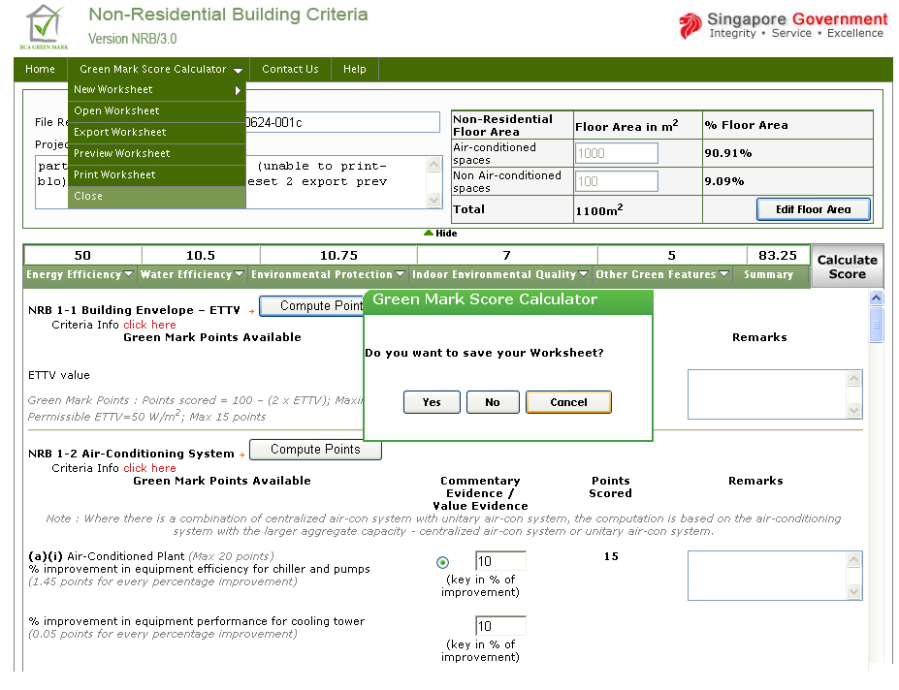

Notes:
- Upon clicking Close will ask for saving the worksheet
- When clicked Yes, will export the worksheet by encrypting the project details section and criteria section.
- When clicked No, will redirect the page to Home Page.
- When clicked Cancel, will not perform any action, which means that the user has cancelled the “close” process.

  - Open Worksheet
Open worksheet page will be opened in a new window.
Notes:
- Upon clicking Browse button will open the file open dialog, to fetch the encrypted file saved before. This is shown below.

Notes:
- Select the encrypted file from the location saved and then click Open. Then click Import Existing Worksheet File, upon clicking the Import Existing Worksheet File button, will determine the criteria section and opens the corresponding page by retrieving the inputs entered and scores obtained. Further data can be entered and exported again.

After “Import Existing Worksheet File”

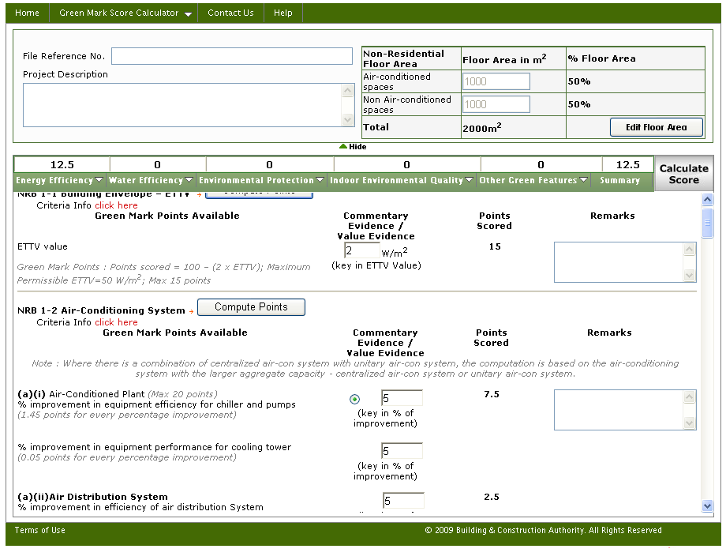

Notes:
- NRB page opens by retrieving the inputs given and the scores obtained for those inputs.

- Green Mark Score Calculator – Contact Us

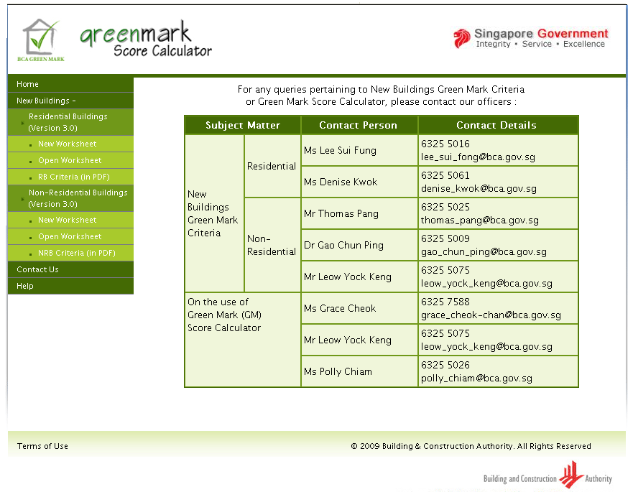

Notes:
- Clicking Contact Us will show the Subject Matter along with Contact persons with contact details in a new window.

